ASSESSMENT-1
Kameshwar R

Bar
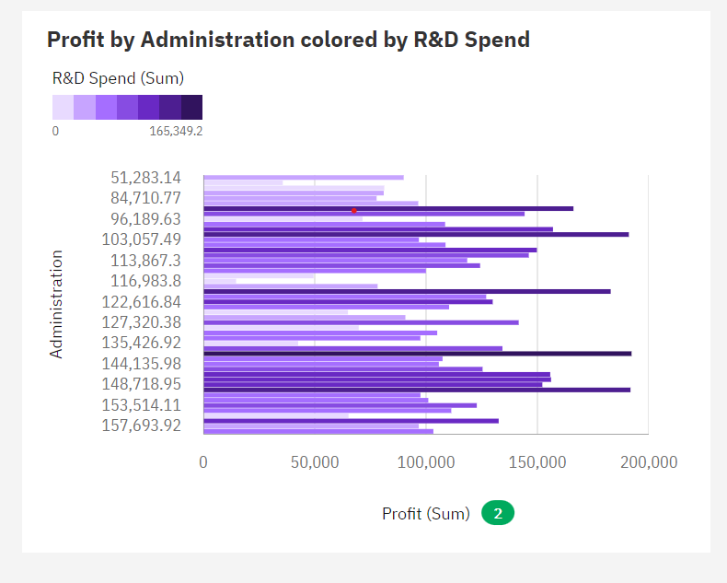

Bullet

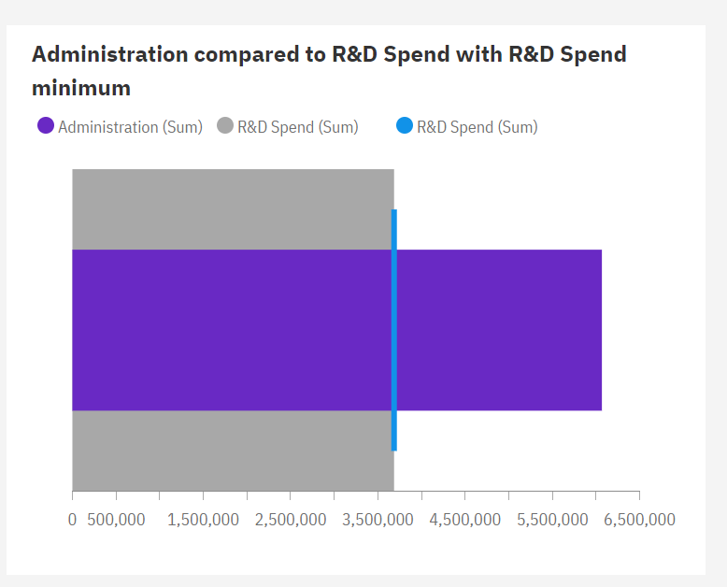

COLUMN

HEATMAP

RADIAL
